 

Student Name

# CAMBRIDGE ENGLISH EMPOWER B1 LISTENING COMPETENCY TEST

## Mid-Course Test

**Time** Approximately 25 minutes

# INSTRUCTIONS TO STUDENTS

Do not open this question paper until you are told to do so. Write your name on this question paper.

Listen to the instructions for each part of the paper carefully. Answer all the questions.

While you are listening, write your answers on the question paper.

# INFORMATION FOR STUDENTS

There are four parts to this test. You will hear each piece twice. Each question carries one mark.

For each part of the test there will be time for you to look through the questions.

© UCLES 2015

## Part 1

**Questions 1 – 5**

You will hear five short conversations. For each question, choose the correct picture. You will hear each conversation twice.

1. What did John take with him on holiday?

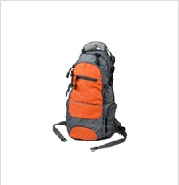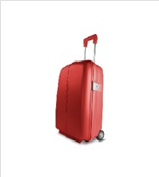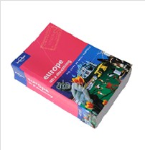

# A x B C

1. Which accessories were most popular last week?



# A x B C

1. What job does John hope to do when he finishes studying?



# A B C x

1. What travel problem particularly annoyed the film director?



# A x B C

1. What does Ellie decide to do?



# A B C x

## Part 2

**Questions 6 – 10**

You will hear a man on the radio talking about his amazing daily journey to work. For each question, write the correct answer in the gap.

**Peter’s Daily Journey to Work**

Peter lives in **(6) york** and travels to London.

Peter’s job is a **(7)** designer .

Peter’s day starts at **(8)** 3:00AM .

Disadvantages:

* Travel costs: £15 000 per year
* Getting tired and **(9) trafic** problems

Advantages:

* Time to **(10)make a plan** for the next day
* The relaxing life at home

## Part 3

**Questions 11 – 15**

You will hear a radio interview with Fiona Baker, an author. For each question, choose the correct answer **A**, **B** or **C**.

1. Fiona became an author because **A** she wanted to as a child. x
   1. her parents advised her to.
   2. she disliked her teaching career.
2. Fiona felt most Russian when **A** she read Russian books.
3. she ate her mother’s food. x
4. she heard her uncle’s stories.
5. Fiona likes to work in a room in her garden because
6. she likes to be close to nature.
7. it reminds her of Russia.

**C** she can be on her own there. x

1. Fiona finds the best time of the year for writing is
2. when it’s cold outside.
3. when the days are longer. x

**c** when the weather changes.

1. Fiona thinks the best way to write a novel is
2. to start small rather than big. x
3. to work backwards from the end.
4. to plan the chapters first.

## Part 4

**Questions 16 – 20**

You will hear a conversation between Jane and Phil discussing a project they’re doing on whether teens should work part-time as well as study.

Decide if each sentence is correct or incorrect.

If it is correct, choose **YES** (✓). If it is incorrect choose **NO** (✓).

# YES NO

1. Jane thinks some teens may need a car. x
2. Phil and Jane agree that when teens work, their schoolwork always suffers. x
3. Phil believes that free-time activities are important for teens’ futures. x
4. Phil thinks that most teens should avoid getting a part-time job. x
5. Jane advises teens to get a summer job. x

**BLANK PAGE**

**BLANK PAGE**